# CS 340 README

## About the Project/Project Title

This script allows for the user to interact with a UI that interacts behind the scenes with the AnimalShelter database. The user can filter via rescue type which will then filter the data table, pi chart, and the geolocation map.

## Motivation

The motivation behind creating this project was to simplify the way that we interact with databases.

## Getting Started

Follow these steps to get started:

## Usage

### Code Example

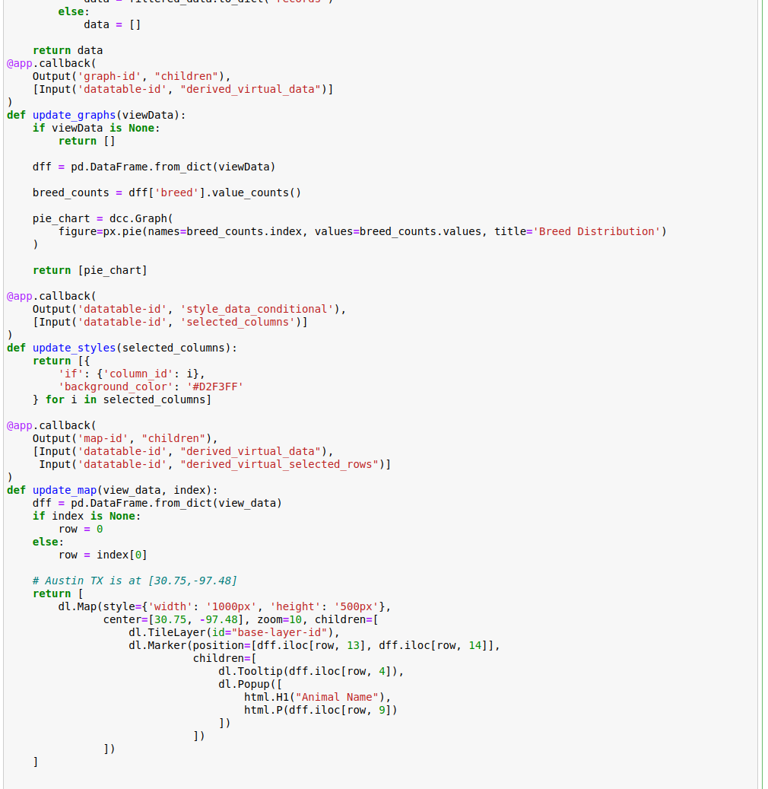

This is a small example of some of the code that runs behind this application.

### Test & Screenshot

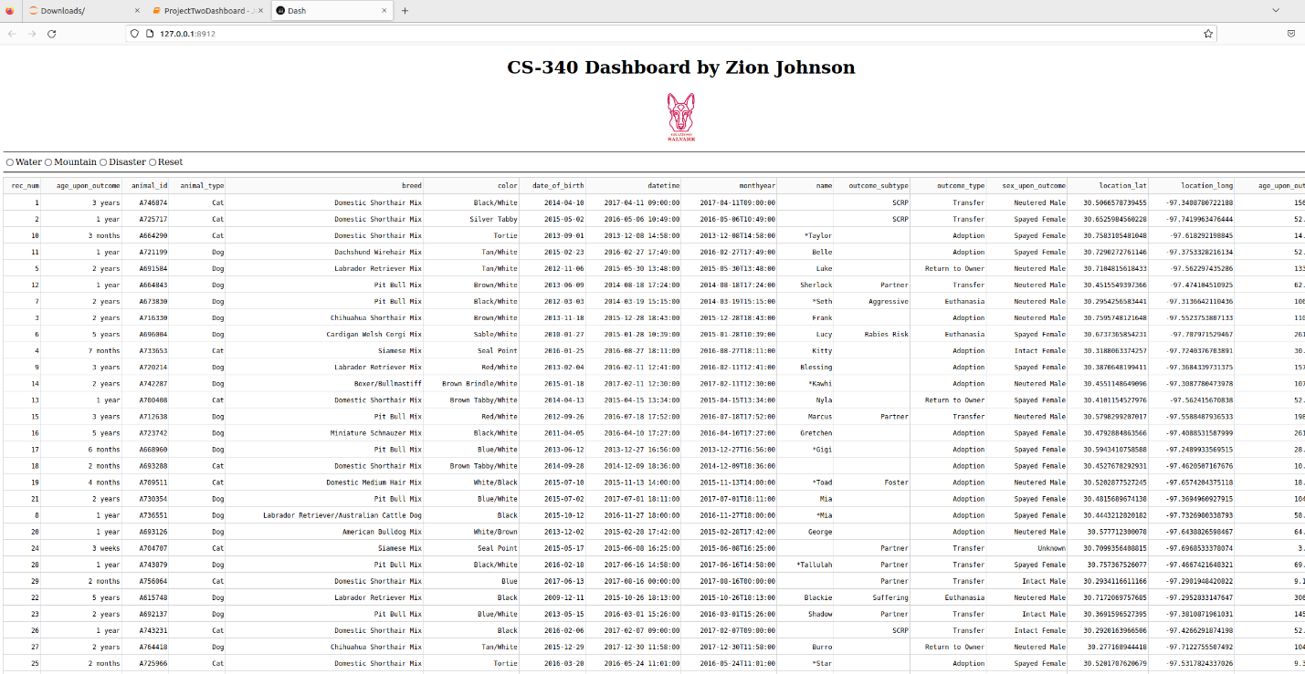

## Roadmap/Features (Optional)

This latest update included adding the data table, pi chart, and geolocation maps. Also included is the ability to filter through all this information making it incredibly easy to find what you are looking for.

## Contact

Zion Johnson

zion.johnson@snhu.edu